PF Lab 06

Syed Badar Ali Naqvi 24K-3079

Q1. Which loop system would be better for user input. Justify your answer by creating a program that takes a value and adds it to a variable and prints it repeatedly until the user enters a zero value.

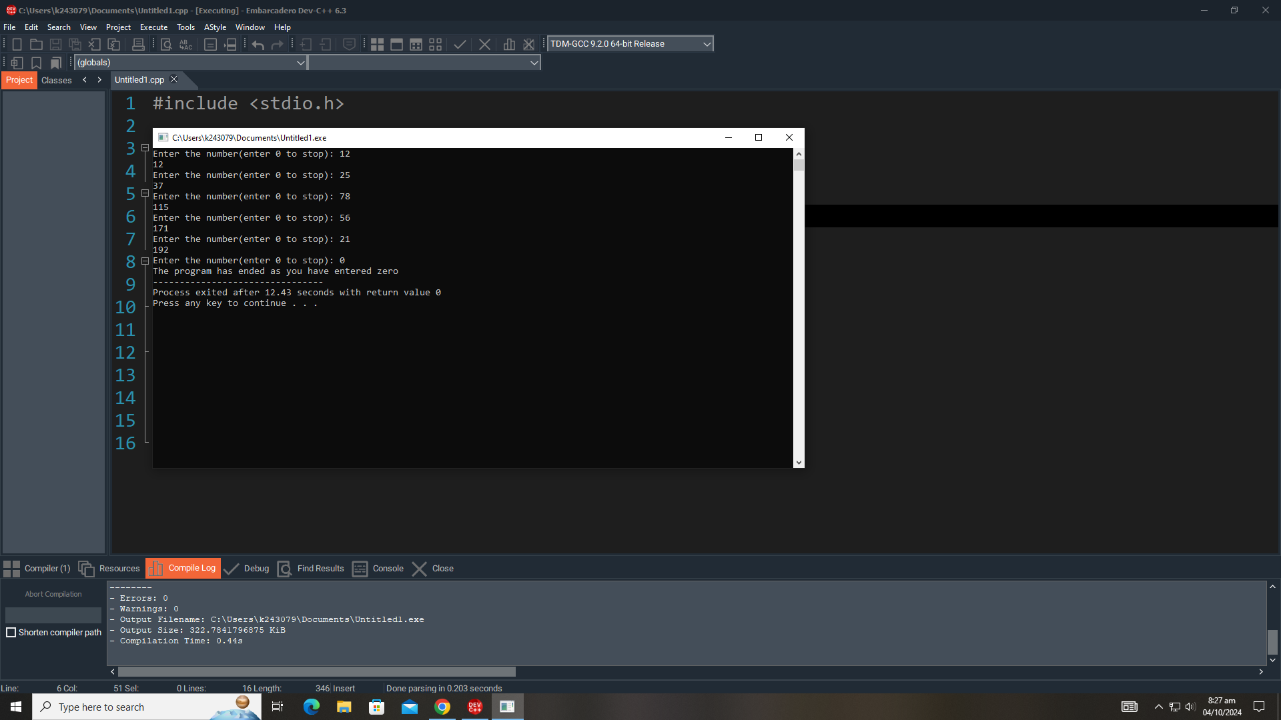

Q2. Write a program to print the multiplication table for a given number up to 10. Take an integer input from the user and displays its multiplication table using for

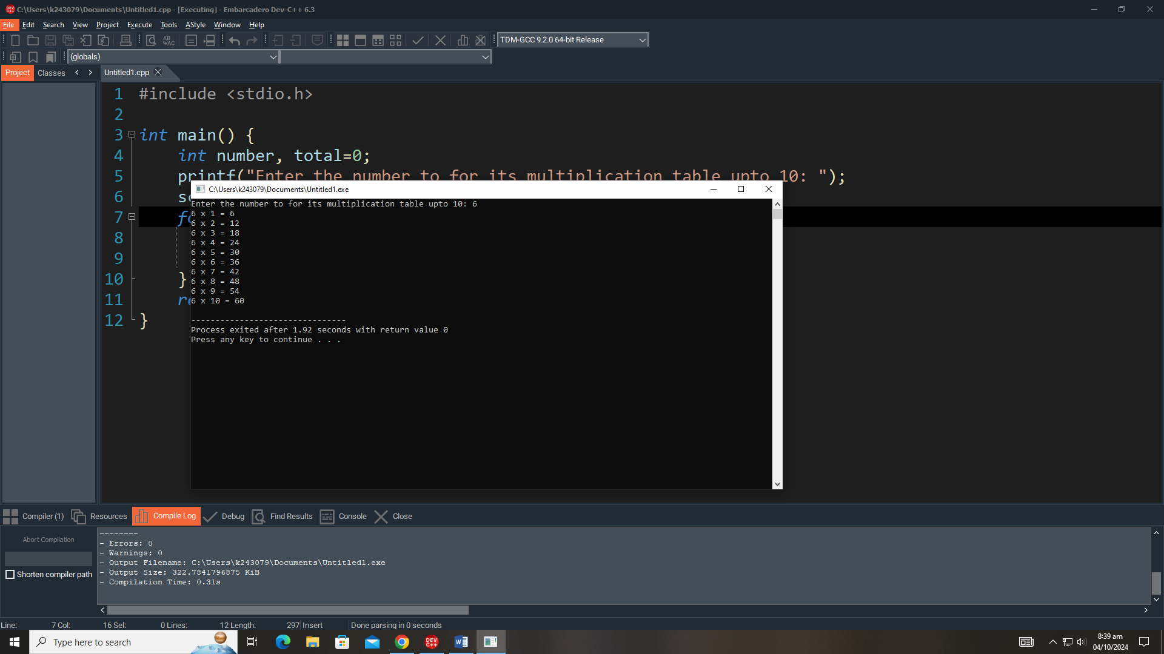

Q3. You are designing a simple ATM withdrawal program. The user can withdraw money until their account balance reaches zero. Use a while loop to repeatedly ask the user how much they want to withdraw. Ensure that they cannot withdraw more than the available balance. After each successful withdrawal, update the balance and display it. (Bank balance = 50,000)

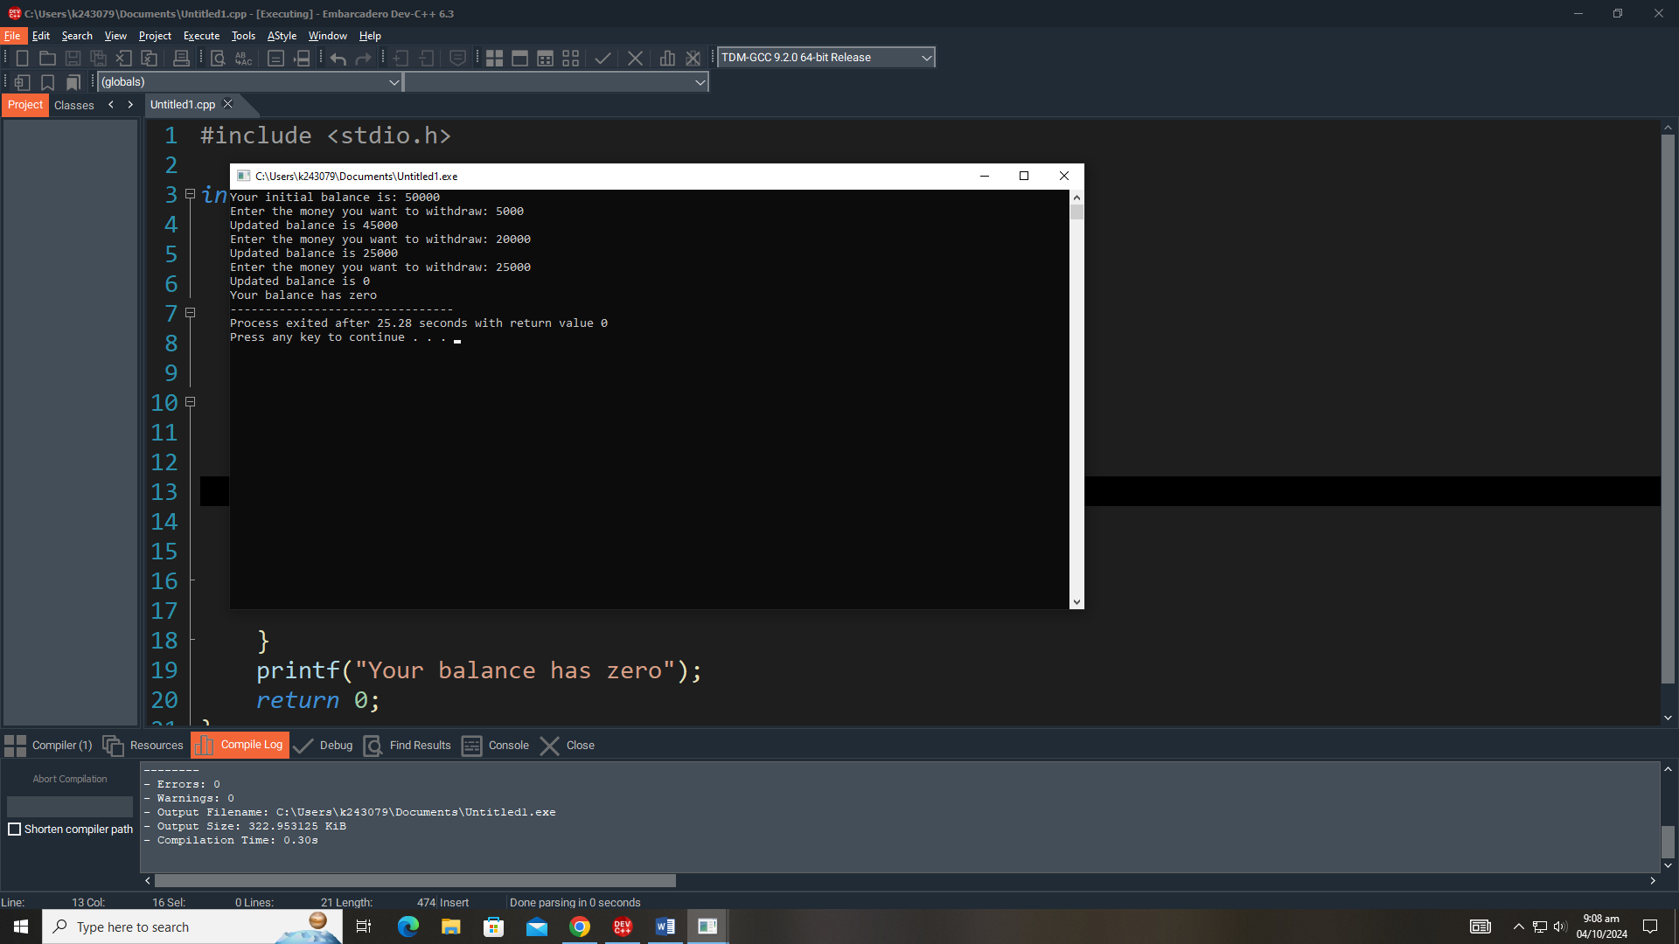

Q4. Write a program to check whether a number is an Armstrong number or not. An Armstrong number is a number that is equal to the sum of cubes of its digits.

